Successful completion of the Second Phase of the Energy Defence Consultation Forum

Bucharest - 12 June, 2019

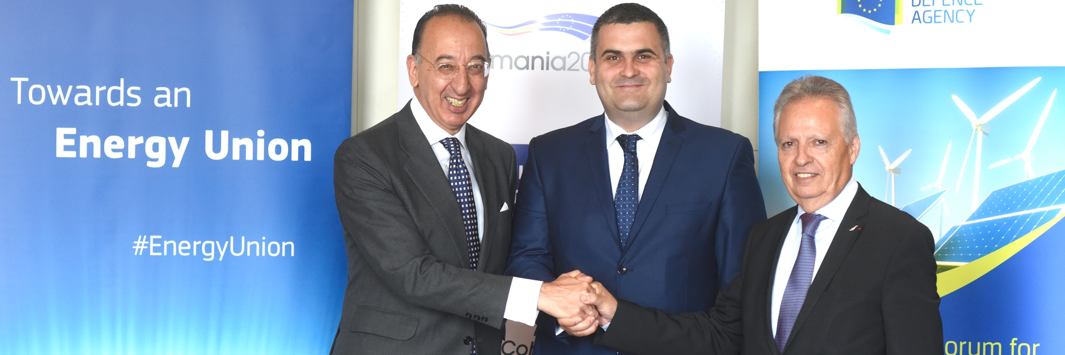

**Over 130 experts from 27 European countries and more than 20 different institutions and organisations participate in the 4th Conference of the Second Phase of the**[**Consultation Forum for Sustainable Energy in the Defence and Security Sector**](%20https:/www.eda.europa.eu/european-defence-energy-network/cf-sedss-phase-ii)**(CF SEDSS II) in Bucharest. The Conference, which is held under the Romanian Presidency of the Council of the European Union and hosted by the Romanian Ministry of National Defence, marks the successful completion of the Second Phase of the CF SEDSS II initiated in October 2017.**  
  
Today’s conference was officially opened by Mr Gabriel-Beniamin Leș, Minister of National Defence of Romania, Mr Dominique Ristori, European Commission Director-General for Energy and Mr Jorge Domecq, Chief Executive of the European Defence Agency (EDA).

Mr Jorge Domecq, EDA Chief Executive, emphasised in his [speech](https://www.eda.europa.eu/docs/default-source/speeches/20190612---4th-sedssii---ce-speech.pdf) that the*“Bucharest conference marks the successful completion of a project which proved that sustainable energy matters for defence and that greener defence energy matters for the European Union”*. The Chief Executive expressed his satisfaction *“as the Consultation Forum has enabled directly or indirectly several Ministries of Defence to develop national defence energy strategies, implement Energy Management Systems, launch projects related to energy performance and consider initiating joint collaborative projects to address common energy challenges”*.

European Commission’s Directorate General for Energy (DG ENER) and the Executive Agency for SMEs (EASME) contributed to the work of the Forum by providing an EU long-term perspective on EU energy legislation, policy and action plans. With the support of the European Commission, the defence sector has come closer to the wider energy community and joined the Union’s efforts to transit to an Energy Union. Mr Dominique Ristori, European Commission Director-General for Energy acknowledged in his introductory speech, *“the substantial work of the Ministries of Defence to apply sustainable energy in the defence sector and to pursue the implementation of the EU legal framework on energy”*.

The second Phase of the Forum developed a more practical defence-centric approach and focused on a range of activities such as improving energy management and energy efficiency of military building stock and fixed infrastructure, the integration of energy sources in defence infrastructure and the protection of defence-related critical energy infrastructure against hybrid threats.

During Phase II the working groups collected more than 30 project ideas, of which 18 were elaborated to comprehensive project proposals. To support their realisation, the Agency applied an internal methodology called “IdentiFunding for Energy”, which matched these ideas with more than 30 eligible funding opportunities, enhancing the probability of their implementation. As a first step, the Agency is currently supporting Ministries of Defence to prepare three (3) applications for funding.

Mr Domecq announced that *“EDA is ready to allocate additional budget to support at least five (5) other applications demonstrating the commitment of the Agency to meet the expectation of the Ministries of Defence in producing tangible results”*.

Next Conference

The Bucharest Conference marked the finalisation of the Second Phase of the Consultation Forum. Currently, EDA and DG ENER are preparing Phase III. It is expected that the first Conference of Phase III will take place during the first quarter of 2020. In the meantime, EDA and DG ENER are also organising a Joint Defence Energy Conference to be held at the end of 2019 in Brussels in preparation of phase III. More information will be uploaded on the [EDA’s dedicated website “European Defence Energy Network (EDEN)](https://eda.europa.eu/european-defence-energy-network/cf-sedss-phase-ii)”

About the CF SEDSS II

The Consultation Forum for Sustainable Energy in the Defence and Security Sector (CF SEDSS) is a European Commission initiative managed by EDA. It aims at bringing together experts from the defence and energy sectors to share information and best practices on improving energy management, energy efficiency, the use of renewable energy as well increasing the protection and resilience of defence energy-related critical infrastructures. On 20 October 2017, the second phase of the Consultation Forum (CF SEDSS II) was launched. This project has received funding from the European Union’s Horizon 2020 research and innovation programme, and the agreement is between the EASME executive agency and the EDA. The contract was signed on 16 October 2017 for 22 months, expiring in August 2019.

Based on the foundations laid during the first phase of the Consultation Forum (2015-2017), the second phase has been further expanded to cover the following interrelated subjects through three main working groups (including sub-working groups): WG 1: Energy Management including Energy Efficiency (Sub-WG1: Energy Management and Sub-WG2: Energy Efficiency; WG 2: Renewable Energy Sources and Technologies; WG 3: Protection of Critical Energy Infrastructure and one cross-cutting theme: Finance.